This template is provided as a starting point for you to build your own customer and prospect-facing security & terms guide. This type of document is often requested by customers and prospects prior to purchasing solutions.
It may be helpful to provide in advance of all implementation projects to ensure customers gain the required approvals in advance for all terms, conditions, policies, and data sharing authorizations.
The final document should be branded and presented as your own, SAP Concur will not maintain or validate the accuracy of the document.
Partner Application
Terms & Security Guide
Template

Last Revised: April 9, 2019

Table of Contents
<Partner Application> Security Overview 1
Section 1: Terms, Conditions, and Privacy Policies for enabling <Application Name> via the SAP Concur App Center 1
Section 2: Terms, Conditions, and Privacy Policies for enabling <Application Name> from the Web Service Admin Menu 1
Section 3: <Partner Name> Data Standards Compliance 3
Section 4: Scopes and APIs Exposed to <Application Name> 3
Section 5: Field Use, Storage, and Deletion for <Application Name> 4

<Before publishing, remember to update the Table of Contents to capture changes made within the document.>

<Partner Application> Security Overview
This guide has been prepared by <Partner Name> to provide guidance on how our <application name> accesses, stores and protects data shared between our solution and the SAP Concur products. To avoid delays, it is best to review this guide thoroughly and gain required approvals for all associated terms and shared information well in advance of the planned activation date.

Terms, Conditions, and Privacy Policies for enabling <Application Name> via the SAP Concur App Center
<Use this section if your app was built utilizing New Auth & delete the section below for Old Auth apps>
Using the SAP Concur App Center, find the <Application Partner Name> listing and click “Connect”. The Terms & Conditions window will appear. This window includes:
- <Partner Name>’s Terms & Conditions (“App Licensing Terms and Conditions”)
- SAP Concur Terms & Conditions (“Company Authorization to Link Services”)
- SAP Concur Privacy Policy (“Processor Privacy Statement”)
- <Partner Name>’s Privacy Policy (“Partner’s Privacy Policy”)

< Please include a screenshot from the App Center that shows your Terms & Conditions window with the Shared Information section expanded. Example below.>
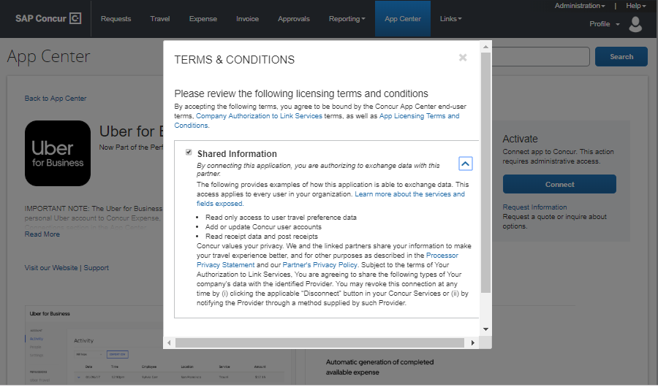

Terms, Conditions, and Privacy Policies for enabling <Application Name> from the Web Service Admin Menu
< Use this section if your app was built utilizing Old Auth and delete the section above intended for New Auth apps. >
At the bottom of the <Partner Application> listing in the SAP Concur App Center, there is a Terms & Conditions link. Here you will find:
- Concur App Center End-User Terms & Conditions
- <Partner Name>’s Terms & Conditions (“App Licensing Terms and Conditions”)
- SAP Concur Terms & Conditions (“Company Authorization to Link Services”)
- SAP Concur Privacy Policy (“Processor Privacy Statement”)
- <Partner Name>’s Privacy Policy (“Partner’s Privacy Policy”)

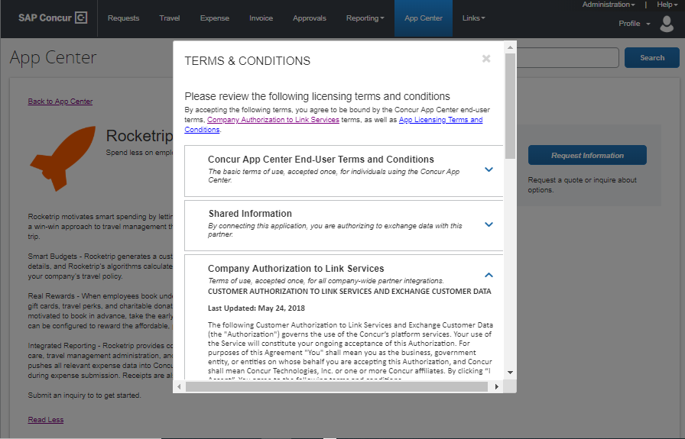
Prior to enabling <Application Name> you will be provided with a copy of the “Company Authorization to Link Services” via a form called the SAP Concur Letter of Authorization or LoA. In accordance with the SAP Concur customer agreements, this document must be signed and returned to us before activating the application.
An authorized administrator of the SAP Concur product within your organization enables the connection. Using the Web Services section under the Administration menu, click on “Enable Partner Application” and find the <Application Name> option. After selecting “Enable” the administrator will be prompted to confirm authorization of the application.
<Please include a screenshot from the Web Services Admin menu with your application highlighted. Example screenshot below. Additionally – you may want to reference the additional steps required to enable your application here.>

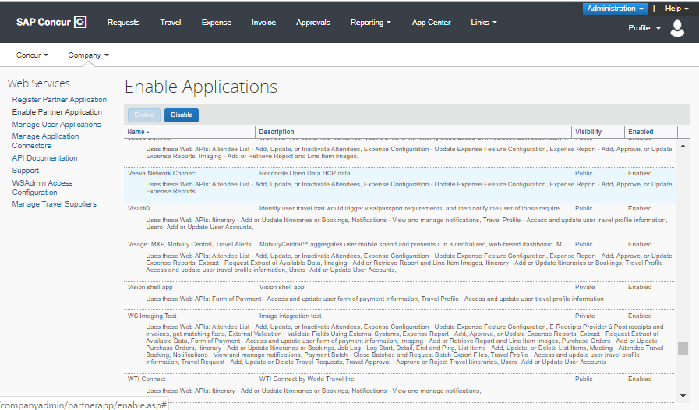

<Partner Name> Data Standards Compliance
< Please provide a description of your data security/compliance protocols including any recognized qualifications or data standards your company/app comply with. >

Scopes and APIs Exposed to <Application Name>
As with every SAP Concur partner application, <Application Name> is published with a set of scopes that control the categories of APIs and specific fields exposed to the solution. At the point that companies enable an application via the SAP Concur App Center, they are authorizing the application to access any fields exposed via that scope. If additional scopes are added to the application later, the application will need to be reauthorized for the new data to be exposed.
<New Auth Text Option>You can view a list of scopes enabled in the Terms & Conditions window described in the previous section under “Shared Information.” The bulleted list of descriptions map to the “User Description” column found on the page linked with the text “Learn more about the services and fields exposed.”
<Old Auth Text Option>You can view a list of APIs enabled in the Enable Partner Application window for our application. The scope names and descriptions listed after the text “Uses These Web APIs” map to the “Scope” and “User Description” columns found here: Partner Application Scope Usage.
The following table provides links to the SAP Concur API documentation that describe the services available to <Application Name>.
<Use https://developer.concur.com/api-reference/authentication/app-center-learn-more.html to copy and paste information for each scope that is enabled for your application to build the table below. You can confirm the scopes enabled via the steps in the section above. The scopes listed below are examples only.>
Scope | Description | Link to API Documents
company.read | Read company profile information | Getting Started, Company API (Profile v1)
receipts.read | Read receipt data | Get Started, Endpoints, Supported Receipt Types, Sample Receipts, Response Codes
receipts.read | Read receipt data | Get Started, Endpoints, Supported Receipt Types, Sample Receipts, Response Codes

Field Use, Storage, and Deletion for <Application Name>
The fields listed below are exposed to <Partner Name> via our App Center integration. We have provided guidance on how we use, store, and protect required data as well as how we dispose of unnecessary data.
<Use this link: https://developer.concur.com/api-reference/authentication/app-center-learn-more.html to build the table below. You will need to click into each API link and copy and paste the Schema section, which lists all exposed fields. See example below.
Note: this section may become very long depending on the APIs used but thoroughly documenting the exposed fields should be helpful for building trust with our joint customer. >

API Name | Field Name | Is the field needed? If so, how is it used? | Accessed? | Stored? | If stored, how is the data kept and protected. | How Disposed?
Digital Tax | Concur Receipt ID | Need the Receipt ID to pull image | Yes | Yes | Text Field | Kept for lifetime of contract
Digital Tax | ID | No | Yes | No | N/A | Deleted immediately
Digital Tax | URI | Need for Receipt | Yes | Yes | Encrypted Field | Deleted from record within 30 days
Digital Tax | Document ID | Yes, used to look up the record if needed later | Yes | Yes | Text Field | Kept for lifetime of contract

